

Press Kit Fosdem 9.0

- About fedora.
- Who uses Fedora ?
- Facts.
- Fedora at FOSDEM'09.
- Some pictures.
- Contact.

About Fedora
Fedora is all about freedom and rapid innovation.

Fedora is a ﻿Linux based operating system that provides users with access to the latest free and open source software, in a stable, secure and easy to manage form. We strongly believe in the bedrock principles that created all the components of our operating system, and because of this we guarantee that Fedora will always be free for anybody, anywhere, to use, modify and distribute.

Fedora is a center for innovation in free and open source software, and creates a community where developers and open source enthusiasts come together to advance free and open source software. The Fedora community contributes everything it builds back to the free and open source world and continues to make advances of significance to the broader community, as evidenced by the regular and rapid incorporation of its features into other Linux distributions. Regardless of which Linux distribution you use, you are relying on code developed within the Fedora Project.

Fedora is more than just software, though. It is a community of contributors from around the world who work with each other to advance the interests of the free culture movement. Everyone is invited to join, and no matter what your skills are, we have a place for you in our community! The Fedora community includes software engineers, artists, system administrators, web designers, writers, speakers, and translators -- all of whom will be happy to help you get started.

Linux Foundation has published a [report] estimating the cost of producing Fedora 9 from scratch to be 10.8 billion dollars and all that value and more is available to you, our users entirely for free with the complete source code and the freedom to innovate.
www.fedoraproject.org

RedHat
The company Red Hat is an US-American software producer with place in Raleigh,
North Carolina, who among other things the wide-spread Linux distribution Red Hat
Enterprise Linux drives out and is involved in the Fedora project. Red Hat Inc. Is at
the US stock exchange NYSE are acted (NYSE: RHT, ISIN US7565771026).
www.redhat.com
Who use Fedora ?

Who uses Fedora?
- Linus Torvalds, the creator and primary maintainer of Linux does
- NASA systems
- Roadrunner, the number one Supercomputer in the world
- Over a hundred derivative distributions including Red Hat Enterprise Linux and OLPC
- Even some Robots do
- Millions of other users

What makes Fedora different?
We try to always do the right thing, and provide only free and open source software. We will fight to protect and promote solutions that anyone can use and redistribute. With this in mind, all of our developers are focused on working closely with upstream, so everyone can benefit from our work and get access to our changes as soon as possible. Due to the huge amount of innovation that Fedora drives, this focus has had significant and long lasting effects. Some of the recent developments in free and open source software that Fedora has driven include:
- NetworkManager
- D-Bus
- PolicyKit
- PackageKit
- HAL
- FreeIPA
- SELinux
- PulseAudio
The reverse is also true: by sticking close to upstream development teams, Fedora often gets the latest software before anybody else. Not only does this benefit our community, but it also benefits the upstream teams by providing a much larger audience and more feedback for them.
Another striking difference of Fedora is our goal to empower others to pursue their vision of what a free operating system should be like. Fedora now forms the basis for derivative distributions such as Red Hat Enterprise Linux , the One Laptop Per Child XO and Creative Commons' Live Content DVDs.
And that's not all. It is just as easy for individuals to create their own distribution, thanks to Fedora's easy spinning tools . These tools allow you to quickly select the packages you want, and create live images for CD/DVD or USB, or installation discs. Some official versions of Fedora have grown up this way, including:
- Fedora Electronic Lab
- Fedora Xfce Spin
- Fedora Developers Spin
- Fedora Games Spin

How do I get Fedora?
Easy, just visit this page and download it. You can try it without installing anything on your computer, thanks to our Live images on CD or USB - in fact, you can even create a Live USB stick from within Windows !
If you have a slow internet connection, or no internet connection at all, then you can still get Fedora thanks to our volunteer Free Media program.

How do I join Fedora?
Like what you see and want to help out? That's easy too! This page has all the information you need, and don't forget that all our contributors get access to some awesome tools to help them get their work done:
- Fedora People provides free webspace for hosting Fedora related content
- Fedora Planet is an aggregation of contributor blogs so you can see what everyone is up to
- Fedora Hosted is the perfect location for hosting your free and open source projects
- Fedora's own Gobby server , so we can collaboratively work on documents in real time
- Fedora Build System to build your software across multiple architectures
- The skills and experience of hundreds of fellow Fedora contributors!

Facts

Current release : Fedora 10 (Cambridge)
Cambridge was released on 2008-11-25.

Yum Data - Current release connections -
Connections to yum
Week | Dates | New Unique IPs | Total Unique IPs | Total compared to Sulphur
Week 1 | 2008-11-25 -- 2008-12-01 | 67,421 | 67,421 | 73%
Week 2 | 2008-12-02 -- 2008-12-08 | 81,674 | 149,095 | 97%
Week 3 | 2008-12-09 -- 2008-12-15 | 60,759 | 209,854 | 97%
Week 4 | 2008-12-16 -- 2008-12-22 | 62,527 | 272,381 | 93%
Week 5 | 2008-12-23 -- 2008-12-29 | 68,375 | 340,756 | 97%
Week 6 | 2008-12-30 -- 2009-01-05 | 73,585 | 414,341 | 97%
Week 7 | 2009-01-06 -- 2009-01-12 | 94,166 | 508,507 | 103%

Total repository connections
Total connections to repositories (as of 2008-01-12)
Method | Fedora 7 | Fedora 8 | Fedora 9 | Fedora 10 | Rawhide | TOTAL
Mixed | 3,470,619 | 4,297,588 | 2,147,104 | 508,507 | 545,692 | 10,969,510
New | 3,493,082 | 4,383,913 | 2,309,190 | 508,507 | 545,692 | 11,240,384
It's uncertain whether the old method was properly counting all unique IPs. The new method works incrementally, and thus takes longer, but should be slightly more accurate.

Accuracy of metrics
The numbers above for yum represent unique IP addresses that reach our update server, not simply downloads. We believe it is reasonable to equate a "new IP address checking in" with "a new installation of Fedora", with the following caveats:
- Users who have dynamic IP addresses will likely be counted multiple times, which inflates the number by some amount.
- Users who are behind NAT or corporate proxies will not be counted at all.
The anecdotal evidence that we receive from different groups, companies, and organizations suggests that group (2) is significantly larger than group (1). As such, we believe that the true numbers in the field are higher than the numbers on this page.

Smolt Data
Smolt is Fedora's hardware profiling project. It is an opt-in database that tracks unique installations of Fedora, and various details about that install. People who install to runlevel 5 will be able to opt-in during firstboot, but people who install to runlevel 3 will have to install the smolt client via yum and manually register.

BitTorrent
The following table shows the number of downloads that have been made over BitTorrent.
Downloads from bittorrent (as of 2008-01-12)
Werewolf (F8) | Sulphur (F9) | Cambridge (F10)
446,326 | 429,236 | 135,137

Direct Download
The following table shows the number of direct downloads of Fedora 10 media, as shown in the web proxy logs.
Direct downloads from the web
Week | Dates | Downloads this week | Total downloads
Week 1 | 2008-11-25 -- 2008-12-01 | 79,635 | 79,635
Week 2 | 2008-12-02 -- 2008-12-08 | 34,903 | 114,538
Week 3 | 2008-12-09 -- 2008-12-15 | 26,925 | 141,463
Week 4 | 2008-12-16 -- 2008-12-22 | 24,558 | 166,021
Week 5 | 2008-12-23 -- 2008-12-29 | 20,708 | 186,729
Week 6 | 2008-12-30 -- 2009-01-05 | 19,336 | 206,065
Week 7 | 2009-01-06 -- 2009-01-12 | 21,408 | 227,473

fedoraproject.org unique visitors
fedoraproject.org visitors
Period | Unique IPs
January 2008 | 785,583
February 2008 | 782,043
March 2008 | 830,078
April 2008 | 723,776
May 2008 | 1,128,115
June 2008 | 825,912
July 2008 | 751,521
August 2008 | 773,209
September 2008 | 1,461,490
October 2008 | 1,351,477
November 2008 | 1,993,547 (all-time monthly high)
December 2008 | 1,873,217

Edits to Fedora wiki
Fedora wiki edits
Period | Total edits | Edits from unique IPs
October 2007 | 921 | 426
November 2007 | 1,090 | 472
December 2007 | 807 | 378
January 2008 | 1,170 | 580
February 2008 | 1,244 | 645
March 2008 | 1,280 | 705
April 2008 | 1,283 | 755

A variety of statistics about Fedora installs, community size, etc. are available at: http://fedoraproject.org/wiki/Statistics
Fedora at FOSDEM'09

Introduction
The ninth Free and Open source Software Developers European Meeting is a 2 day event, organized by volunteers, to promote the widespread use of Free and Open Source software. Taking place in the beautiful city of Brussels (Belgium), FOSDEM meetings are recognized as "The best Free and Open Source events in Europe."

Location and Date
- Brussels, Belgium
- 7 and 8 February 2009
- Attendance is free.
- Parking is Free
- ULB University (the French one)

URL
http://www.fosdem.org
https://fedoraproject.org/wiki/FedoraEvents/FOSDEM/FOSDEM2009

Schedule
Salle : H.2213
 | Saturday 7th | Sunday 8th
10:00 – 11:00 | N/A | CentOS Reserved Slot
11:00 – 12:00 | N/A | CentOS Reserved Slot
12:00 – 13:00 | N/A | CentOS Reserved Slot
13:00 – 14:00 | RPM Packaging | CentOS Reserved Slot
14:00 – 15:00 | Fedora Electronic Laboratory | CentOS Reserved Slot
15:00 – 16:00 | Fedora-fr Next challenges | Cobbler/Koan
16:00 – 17:00 | Func, Symbolic: Present and future | FreeIPA
17:00 – 18:00 | Sugar and Fedora | N/A
18:00 – 19:00 | Augeas

Session
Fedora Electronic Lab
Title : Fedora Electronic Lab
Abstract : Fedora's Electronic Laboratory is dedicated to supporting the innovation and
development of opensource EDA community along with a history of experience in multiple applications.
Longer Description : Fedora Electronic Laboratory provides a complete electronic laboratory setup with reliable open source design tools in order to meet one's requirements to keep one in pace with current technological race. Project management tools such as spreadsheet, gantt diagram, mindmapping tools.... are also included.
URL : http://chitlesh.fedorapeople.org/FEL/
Speaker : Chitlesh Goorah
Bio : Chitlesh is a postgraduate student in Micro-Nano Electronics at the University of Louis Pasteur . He is also holding a intern position in VLSI design at ON Semiconductor (former AMI Semiconductor).
email : chitlesh@fedoraproject.org
JabberID :
URL : https://fedoraproject.org/wiki/ChitleshGoorah
Cobbler/Koan
Title : Cobbler/Koan
Abstract : Cobbler is a Linux installation server that allows for rapid setup of network installation environments.
Longer Description : Most deployments of Linux systems are very rarely just one or two systems. Once you get past just installing Linux on your home system or your workstation it is time to think about how you are going to manage installing, and if required re-installing, these groups of systems in a repeatable manner. This is where Cobbler and Koan come in.
Cobbler is a next generation systems management tool designed to keep a track of not just your systems but the initial system deployment configuration, host networking and even the configuration management. Koan provides the same facilities in the new world of systemvirtualization.
During this talk we aim to demonstrate just how easy Cobbler and Koan make keeping track of your Linux deployments and configurations.
URL : https://fedorahosted.org/cobbler/
Speaker : Robert Lazzurs
Bio : Robert has been a UNIX systems administrator for 8 years now first at ISP's and small businesses and now for TomTom in our Edinburgh office. He has used RedHat and Fedora for most of the professional career.
email : rob@lazzurs.net
lazzurs@gmail.com
JabberID :
URL : http://www.lazzurs.net/
http://www.lazzurs.net/
Speaker : Jasper Capel
Bio : Jasper live in The Netherlands. I'm involved with the Cobbler project
email : capel@stone-it.com
JabberID :
URL : https://fedoraproject.org/wiki/JasperCapel

FreeIPA
Title : FreeIPA
Abstract : FreeIPA is an integrated security information management solution combining Linux (Fedora), Fedora Directory Server, MIT Kerberos, NTP, DNS. It consists of a web interface and command-line administration tools. Currently it supports identity management with plans to support policy and auditing management.
Longer Description :
URL : http://www.freeipa.org/page/Main_Page
Speaker : Simo Sorce
Bio :
email : ssorce@redhat.com
JabberID :
URL :

Augeas
Title : Augeas
Abstract : Augeas is a configuration editing tool. It parses configuration files in their native formats and transforms them into a tree. Configuration changes are made by manipulating this tree and saving it back into native config files.
Longer Description : One of the many things that makes Linux configuration management the minefield we all love is the lack of a local configuration API. The main culprit for this situation, that configuration data is generally stored in text files in a wide variety of formats, is both an important part of the Linux culture and valuable when humans need to make configuration changes manually. AUGEAS provides a local configuration API that presents configuration data as a tree. The tree is backed directly by the various config files as they exist today; modifications to the tree correspond directly to changes in the underlying files. AUGEAS takes great care to preserve comments and other formatting details across editing operations. The transformation from files into the tree and back is controlled by a description of the file's format, consisting of regular expressions and instructions on how to map matches into the tree. AUGEAS currently can be used through a command line tool, the C API, and from Ruby, Python, and OCaml. It also comes with descriptions for a good number of common Linux config files that can be edited "out-of-the-box."
URL : http://augeas.net/
Speaker : Raphael Pinson
Bio : Raphael is a Linux system administrator, focusing on Debian packaging, configuration deployment and automation of infrastructure systems. His involvement in open-source has led him to participate in the Kubuntu project as an Ubuntu developer, and lately he has been contributing to the Augeas project.
email : raphink@gmail.com
JabberID : raphink@jabber.fr
URL : http://raphink.info

RPM packaging
Title : RPM packaging
Abstract :
Longer Description :
URL :
Speaker : Christophe Wickert
Bio : Christophe work for Fedora as a Package Maintainer. ATM He is maintaining nearly all the Xfce-Goodies, most of the LXDE Packages and some other stuff (~ 70 packages).
email : cwickert@fedoraproject.org
JabberID :
URL : https://fedoraproject.org/wiki/ChristophWickert

Future Fedora-fr challenges
Title : Future Fedora-fr challenges
Abstract : Fedora organization in French speaking country.
Longer Description : Fedora-fr is a non profit organization mainly active in France. Now that the organization is well organized and going to have its head renewed for the first time at the beginning of this year, Fedora-fr has to meet other French speaking Fedora addicts in foreign countries, and see how it can help them buzz about Fedora and organise events in their own areas.
URL :
Speaker : Thomas Canniot
Bio : Former English student, Thomas Canniot is the President of Fedora-fr, the French speaking non profit organization which actively promote Fedora in French in France. With the help of over motivated French ambassadors a very active website could have been set up, providing free services in French around fedora : forum, IRC channel, blogging plateform, help to join the Project, help for packaging.
email : mrtom@fedoraproject.org
JabberID :
URL : https://fedoraproject.org/wiki/ThomasCanniot

Func, Symbolic: Present and future
Title : Func, Symbolic: Present and future
Abstract :
Longer Description : Theory and demo. In the first part will be a short explanation about what are func and symbolic, and (in particular for symbolic) what are future plans. In the second part will be how set-up func and symbolic and hot they work.
URL : https://fedorahosted.org/func/
Speaker : Francesco Crippa
Bio : He is a "Senior Solutions Architect". I design and build enterprise architectures based on Linux, Java and some other funny stuff
email : fcrippa@byte-code.com
JabberID :
URL : https://fedoraproject.org/wiki/FrancescoCrippa
Speaker : Luca Foppiano
Bio : Luca started to use Linux several years ago. Right now, he is developer at Byte-code Srl, a small Italian IT company. He is a Fedora Ambassador and contributor since May 2008.
email : lfoppiano@byte-code.com
JabberID :
URL :

Sugar: what is and why Fedora might care
Title : Sugar: what is and why Fedora might care
Abstract : Introduction to Sugar and SugarLabs, strategic importance it might have for Fedora and GNOME, and synergy with other projects Fedora cares about.
Longer Description :
URL : http://sugarlabs.org
Speaker : Tomeu Vizoso
Bio : Sugar developer since Oct 2006, contracted by OLPC for 2 years and now back a volunteer.
email :
JabberID :
URL : http://sugarlabs.org/go/User:Tomeu
Speaker : Greg DeKoenigsberg
Bio : He does open source community work for Red Hat.
email : gdk@redhat.com
JabberID :
URL : https://fedoraproject.org/wiki/GregDeKoenigsberg

Some pictures

Logo 1
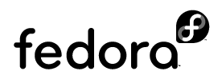
Logo 2

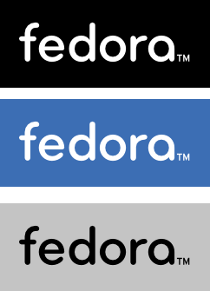

Logo 3 Logo4L

Logo/UsageGuidelines : https://fedoraproject.org/wiki/Logo/UsageGuidelines
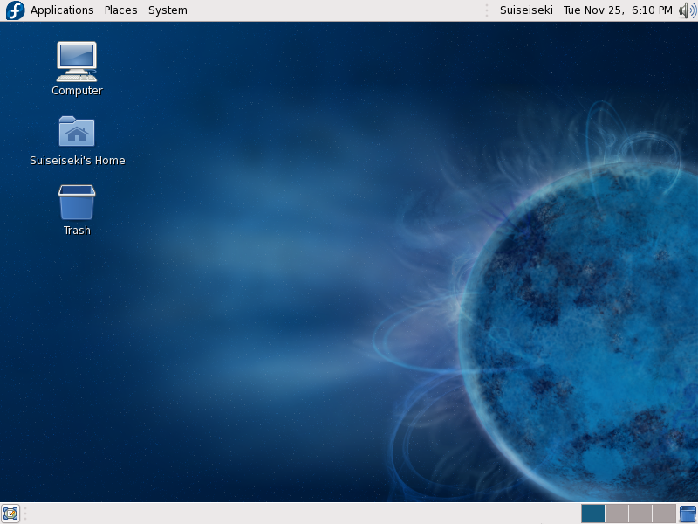
Gnome Desktop
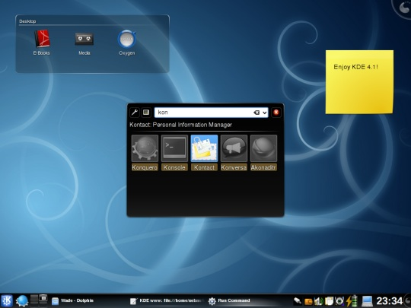
KDE Desktop

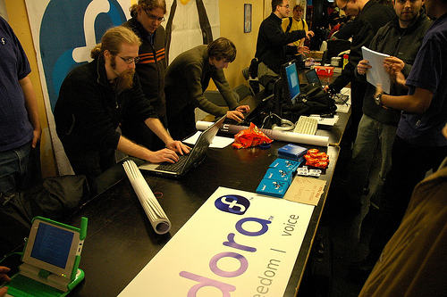
Fedora Community at FOSDEM'08

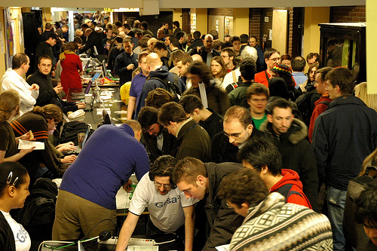
Fedora Community at FOSDEM'08

Contacts
Fedora Marketing Team
press@fedoraproject.org
http://fedoraproject.org/wiki/Marketing/Press

Max Spevack
Fedora EMEA Leader
mspevack@redhat.com
http://spevack.org/

Frédéric Hornain
Fedora at FOSDEM'09
fhornain@gmail.com

